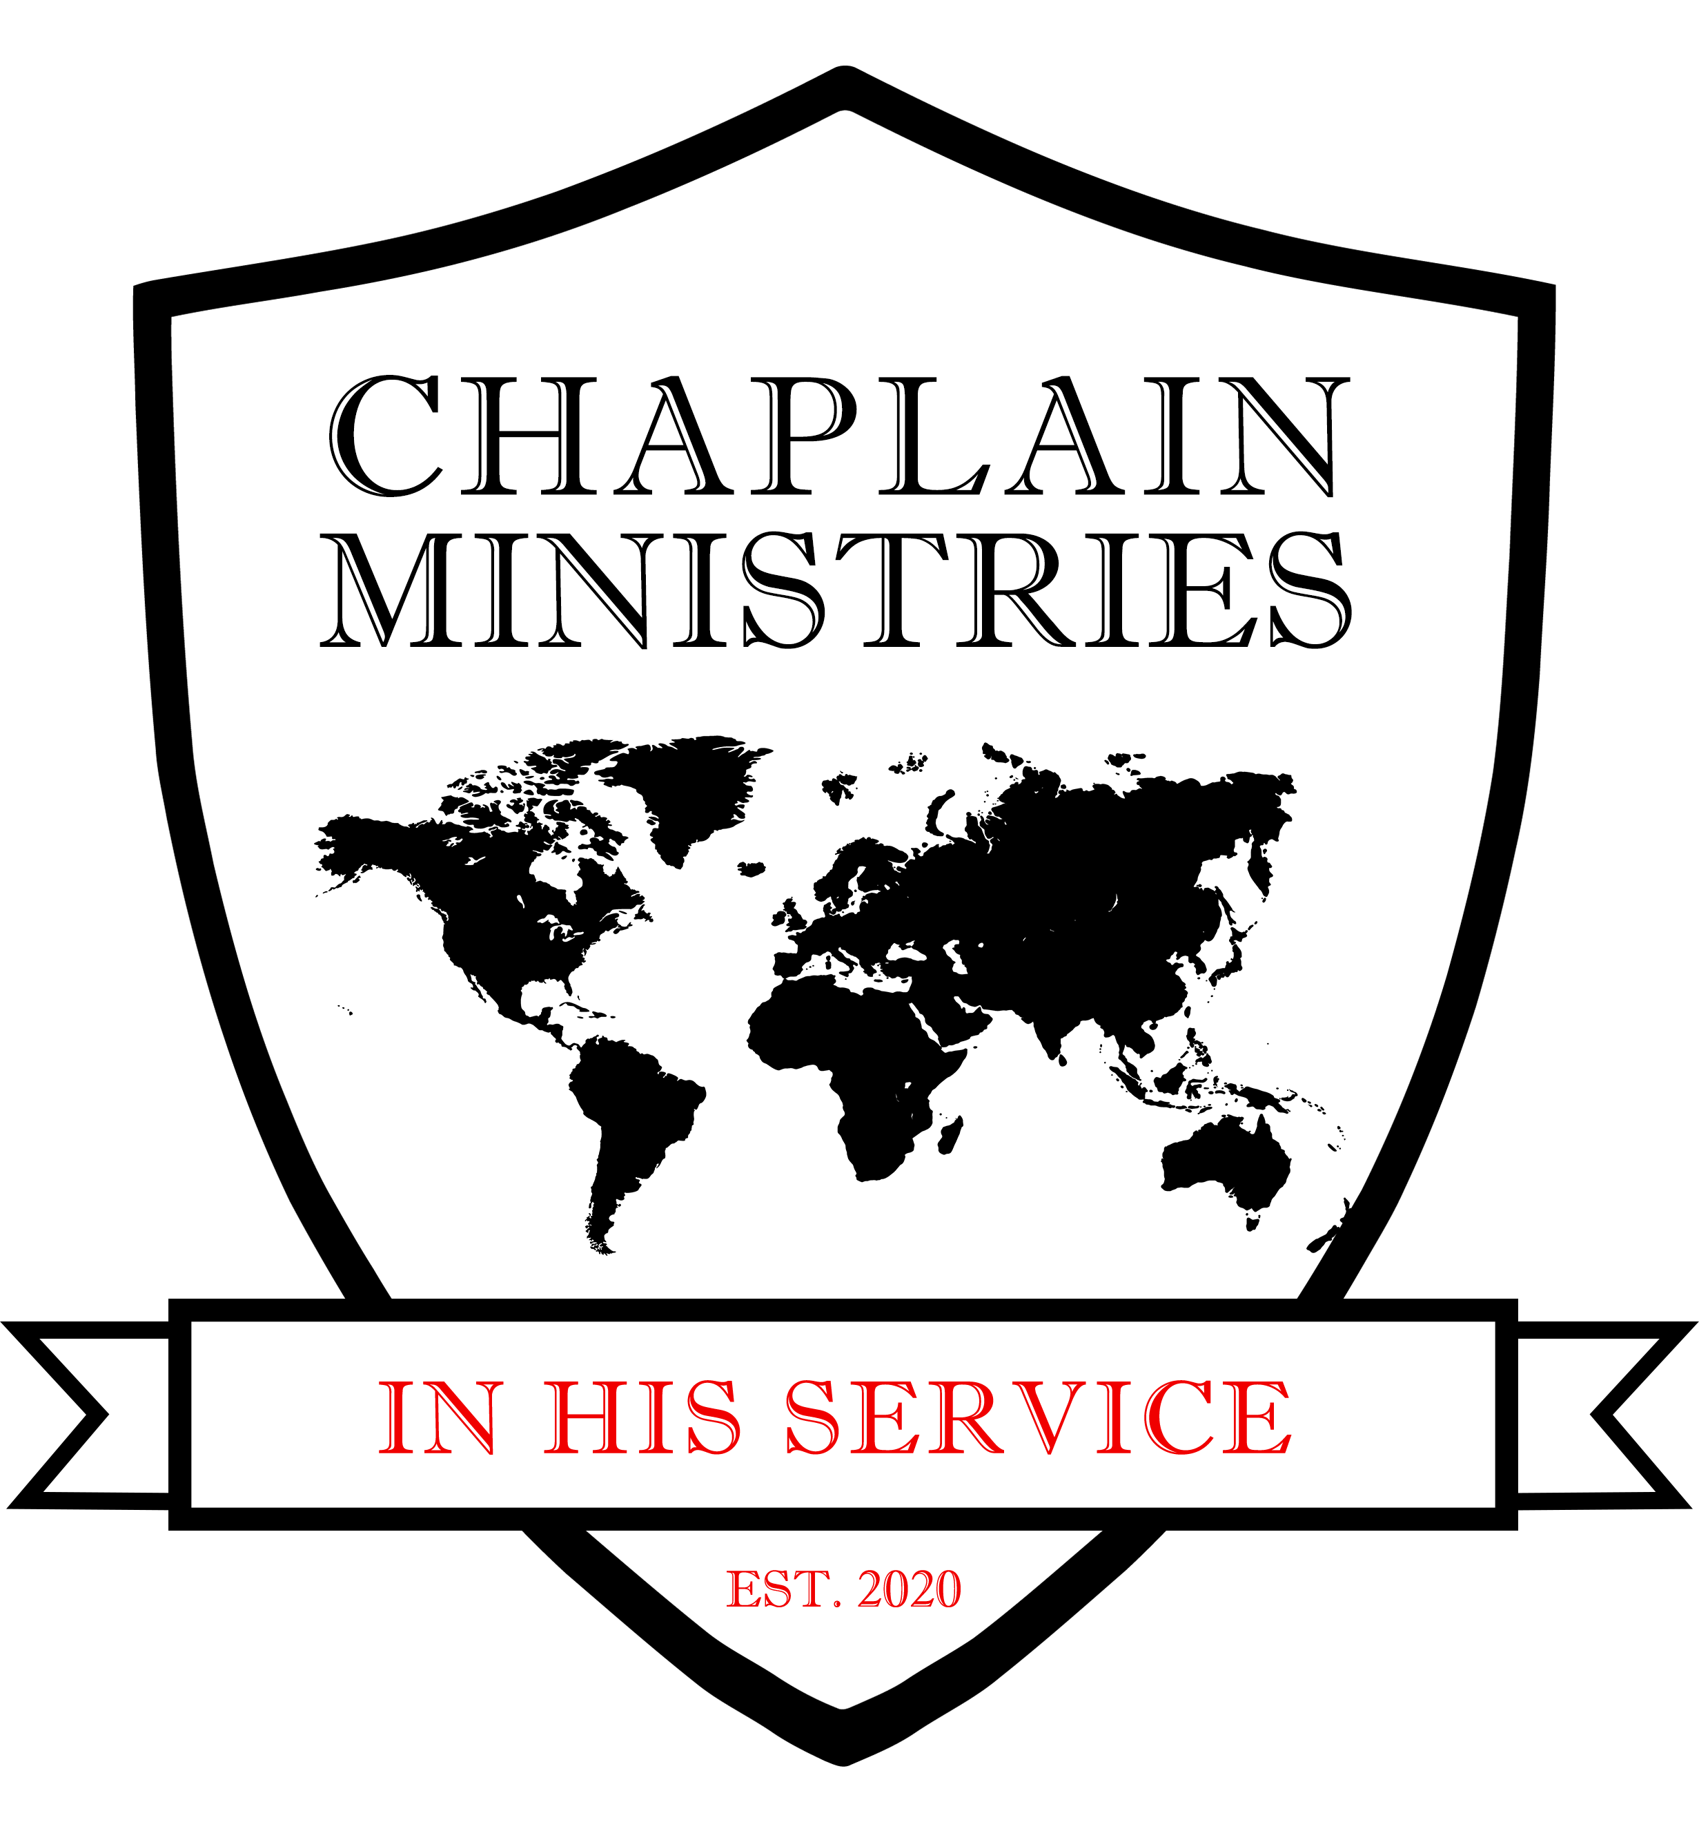

|  |
| --- |
|  |
| **Chaplain Ministries of Maui/Georgia**  PO Box 283  Midway, Ga 31320  Dear Chaplain Prospect;  The Chaplaincy Certification is $300.00 which includes the 3hours of an in person/zoom Intro To Chaplaincy Training and 30 hours of additional self training that you may complete on your own. This fee also includes your Licensing, Ordination and Badge. (Personalized, Custom Badges can be ordered separately for a separate fee as well) Personalized Badges will only be on order after your License and Ordination has been released and may take up to 8 weeks for delivery.   * Please send a copy of your Drivers License. * You will need 2 Letters of Reference. * You will need 2 passport photos. (which you may take yourself if front of a white wall) * You will also need a ministry or volunteer resume along with any ministry or ordination and college degrees.   (Please sign below for completion).  __________________________________________ _____________  Print Name / Signature Date  Sincerely,  ***Chaplain Leah Smith / CEO***  Chaplain Ministries Of Maui / Georgia  *Local Line: 808.897.0527*  *Business Line 813.699.9138*  *Email:* [*office@cmomaui.com*](mailto:office@cmomaui.com)  *Website: www.cmomaui.com* |
|  |